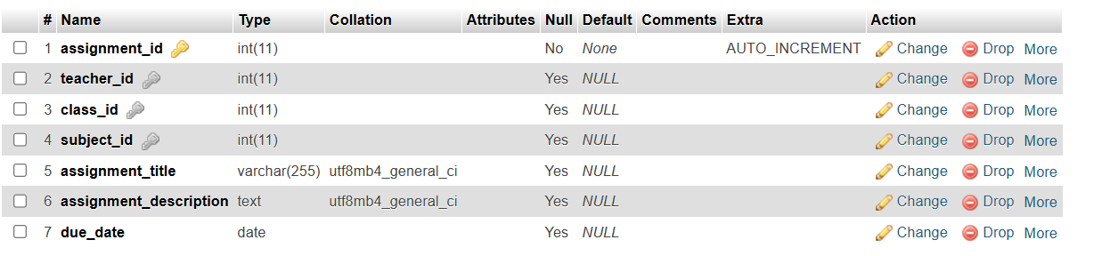Before

After

